Name:______________________
The Nitrogen Cycle

All living things need nitrogen, because nitrogen is an important element in P_________ molecules. The chemical symbol for nitrogen is _______.
_______% of the atmosphere is nitrogen, but most living organisms cannot use this nitrogen. The nitrogen in the atmosphere is form of N₂ gas. Nitrogen gets into the food web, when plants soak up nitrogen from the s___________. The plants absorb this nitrogen in form of water soluble n___________ (NO₃). Nitrates along with phosphates and sulphates are important soil nutrients and are often added to soils in fertilizers.

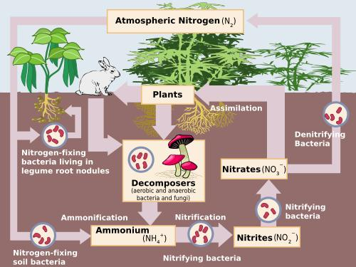

The nitrates can get into the soil in a number of ways:
- L_______________. Lightening changes N₂ gas into nitrates (NO₃) and rain washes the nitrates into the soil.
- D_________. Bacteria and fungi are decomposers that break down dead and decaying matter and return the nitrates to the soil. We call these decomposers saprophytes.
- F__________. People can add fertilisers, which contain nitrates, to the soil.
- L___________. Legumes are plants that convert nitrogen form the air into nitrates that can be used by the plant. Legumes include peas, beans, lupins and clover. They have special “bumps” on their roots called nodules. These nodules are full of special bacteria, which convert the nitrogen to nitrates. We call these bacteria “nitrogen fixing bacteria”. This is an example of symbiosis. Symbiosis is where two different types of organisms live together to help each other survive. In this case the bacteria get food (simple sugars) and somewhere to live. Legumes are important plants in areas where the soil is poor and does not contain nutrients such as nitrates.
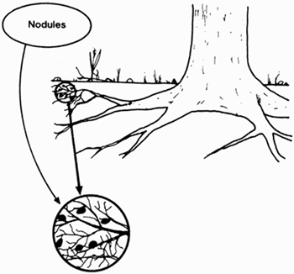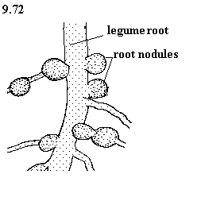

1.
Word | Meaning
Saprophytes
Symbiosis
Legumes
Decomposer
Nodules
N
N₂
Nitrogen fixing bacteria | Bacteria which convert atmospheric nitrogen (N₂) into nitrates (NO₃).

2. In areas with poor soils, people will often grow beans as a food source. Can you give a reason for this?

Nitrogen Cycle

H | C | A | G | S | H | S | M | F | F | G | X | N | E | L
C | N | L | V | N | Y | V | J | T | M | N | Y | I | T | Z
B | E | A | N | S | I | M | H | Y | I | I | R | T | Y | P
Z | Q | M | H | V | M | N | B | H | E | X | N | R | H | O
U | R | C | Y | N | X | S | E | I | N | I | U | O | P | Z
U | D | Z | H | S | M | I | E | T | O | F | U | G | O | X
A | I | R | E | T | C | A | B | T | H | S | U | E | R | U
E | R | E | H | P | S | O | M | T | A | G | I | N | P | I
S | N | G | E | R | Q | N | D | W | T | R | I | S | A | V
F | P | U | A | N | S | J | U | D | S | P | T | L | S | E
N | U | I | L | M | O | Y | B | U | U | C | K | I | B | U
I | N | N | K | E | I | L | R | L | Y | K | N | H | N | P
A | C | S | G | G | L | S | A | E | P | P | D | K | U | J
U | S | K | W | I | I | E | Z | Q | Y | V | P | I | L | Z
F | E | R | T | I | L | I | S | E | R | P | D | B | G | O

ATMOSPHERE | BACTERIA | BEANS
FERTILISER | FIXING | FUNGI
LIGHTENING | LUPIN | NITRATES
NITROGEN | PEAS | RAIN
SAPROPHYTE | SOIL | SYMBIOSIS

